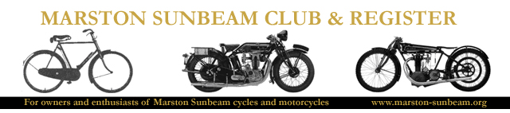
THE 2023 DEE VALLEY DETOUR IS ON!

Please can you inform any Members/friends who may be thinking of attending but not on email, that they are more than welcome to join us.

THE DATE IS - SUNDAY THE 24TH SEPTEMBER 2023.

10.00AM – SIGNING ON WITH TEA AND BACON ROLLS PROVIDED TO PURCHASE. Please display your machines at the front of the hall prior to and after the run.
11.00AM – FIRST BIKE AWAY. This may vary slightly, dependant on the popularity of Claire’s bacon rolls!
3.00PM – FINISH AND AWARDS.

THE VENUE IS - BANGOR ON DEE VILLAGE HALL, OVERTON ROAD, BANGOR ON DEE, LL13 OBY.
http://www.bangorondeecommunitycouncil.co.uk

We have hired the Hall for the day with the kind permission of the Villages’ Community Council who have actually welcomed us back after last year’s tremendous support from the local community.

We have full facilities, an area at the front to display your machines and a private car park for around 10 vehicles for our sole use with on road parking near-by.
This is located directly behind the Parish Church and 20 yards from the Buck House Hotel.

The run itself is mostly the established route with the test of man and machine up the pass and down the lanes of this fabulous part of the world. Around 55 miles with plenty of time and stops to meet up with your friends and fellow enthusiasts and a breakdown van provided. (which I am sure will not be needed...ahem)

All Sunbeam machines from 1912 to 1940 welcome along with our friends on other Marques and of course the support riders.

We look forward to seeing as many of you as possible for this season closing run for our Marston Sunbeam Club & Register Region – please do get in touch, a phone call is fine, if you intend coming which will help with buying enough Tea, Bacon and Buns! (Vegetarian option available but PLEASE DO LET ME KNOW IN ADVANCE).

The Marston Sunbeam Club & Register is a company limited by guarantee registered in England and Wales: Registration No. 7230550. Registered Office: Lewis Onions Solicitors, Allium House, 36 Water Street, Birmingham B3 1HP

